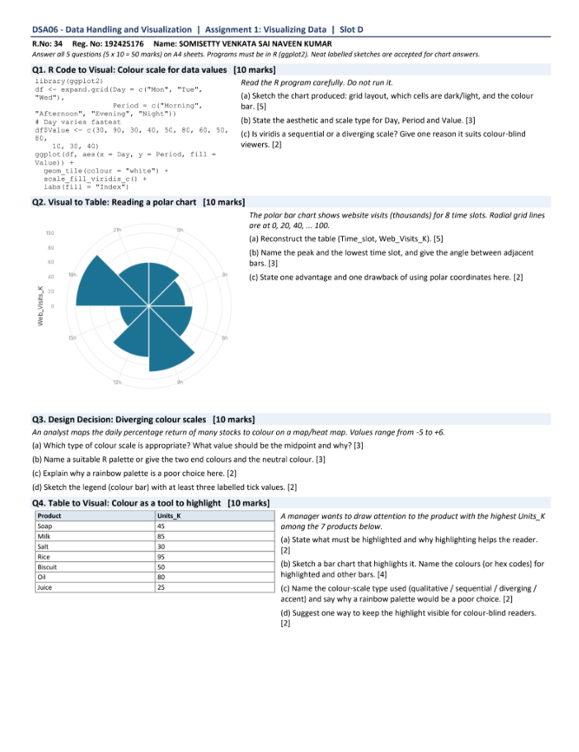
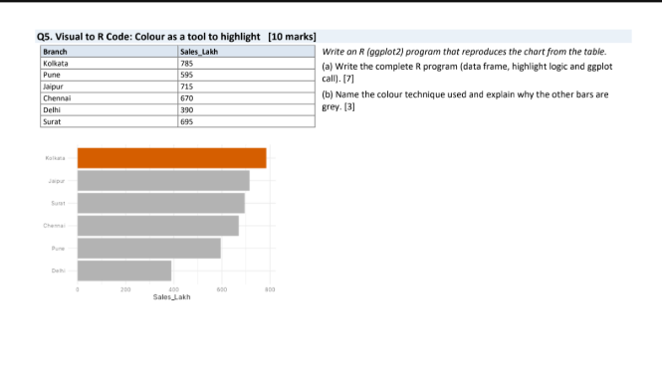

Q1. R Code to Visual: Colour scale for data values
Reading the code: expand.grid() builds every Day x Period combination (Day varies fastest), a numeric Value is attached to each row, and geom_tile() draws one rectangle per row, filled by Value using the viridis continuous scale.

(a) Sketch of the chart [5]
- Layout: a heat map with 3 columns (Mon, Tue, Wed along the x-axis) and 4 rows (one per Period on the y-axis). That gives 12 tiles in total.
- Row order: expand.grid() turns Period into a factor in the order given, and ggplot puts the first level at the bottom. So Morning is the bottom row, then Afternoon, Evening, and Night at the top.
- Tile colours: low Values are dark (deep purple/blue), mid Values are teal/green, and the highest Values are bright yellow. Tiles with Value 10 are the darkest and tiles with Value 60 are the brightest.
- Tile borders: each tile has a thin white outline (colour = "white"), so the grid lines look white.
- Legend: a vertical continuous colour bar on the right titled "Index", running from dark (low) to yellow (high).
Period \ Day | Mon | Tue | Wed
Night (top row) | colour by Value | colour by Value | colour by Value
Evening | colour by Value | colour by Value | colour by Value
Afternoon | colour by Value | colour by Value | colour by Value
Morning (bottom row) | colour by Value | colour by Value | colour by Value

(b) Aesthetic mappings and scale type [3]
- Day is mapped to x (categorical).
- Period is mapped to y (categorical).
- Value is mapped to fill (continuous numeric).
Scale type: scale_fill_viridis_c() is a continuous colour scale (the "_c" stands for continuous).

(c) Sequential or diverging? [2]
viridis is a sequential scale: it runs in one direction from dark (low) to light yellow (high) with no meaningful midpoint. One reason it suits colour-blind viewers: it is perceptually uniform and its lightness increases steadily from low to high, so values can be told apart by brightness alone, without relying on a red-green hue difference.

Q2. Visual to Table: Reading a polar chart [10 marks]
The chart is a polar bar chart with 8 equal wedges (one per time slot) and radial grid lines at 0, 20, 40, 60, 80, 100 (Web_Visits_K, in thousands).
Note: values below are approximate readings from the screenshot against the radial grid lines. Please compare them with your original chart and adjust if needed.

(a) Reconstructed table (Time_slot, Web_Visits_K) [5]
Time_slot | Web_Visits_K (approx.)
Slot 1 | ≈ 60
Slot 2 | ≈ 100
Slot 3 | ≈ 80
Slot 4 | ≈ 40
Slot 5 | ≈ 20
Slot 6 | ≈ 60
Slot 7 | ≈ 80
Slot 8 | ≈ 40

(b) Peak, lowest, and angle between adjacent bars [3]
- Peak: the longest wedge, reaching about the 100 ring (about 100K visits), is Slot 2.
- Lowest: the shortest wedge, reaching only about the 20 ring (about 20K visits), is Slot 5.
- Angle between adjacent bars: 360° / 8 slots = 45°.

(c) Advantage and drawback of polar coordinates [2]
- Advantage: polar charts suit cyclical data such as time of day, because the last slot wraps around and connects to the first.
- Drawback: bar lengths and wedge areas are harder to compare accurately than bars on a straight axis, and outer wedges look bigger than inner ones. Exact values are also harder to read.

Q3. Design Decision: Choosing colour scales [10 marks]
Context: an analyst maps the daily percentage return of many stocks to colour on a map/heat map. Values range from -5 to +6.

(a) Which type of colour scale and the midpoint [3]
A diverging colour scale is appropriate. The data has a natural, meaningful centre at 0 (no change), with losses below and gains above. The midpoint should be 0, so that negative and positive returns get different hues and the size of the change is shown by the colour intensity.

(b) Suitable palette [3]
- Two end colours: red for negative returns (losses) and blue for positive returns (gains).
- Neutral colour: white or very light grey at 0.
Red-blue (for example RdBu) is preferred to red-green because it stays distinguishable for people with red-green colour blindness.

(c) Why a rainbow palette is a poor choice here [2]
A rainbow palette has no natural neutral midpoint, so zero (no change) does not stand out. Its hues are not perceptually uniform: bright bands (yellow, cyan) look like boundaries that are not in the data. It also has no intuitive order from low to high, and it is hard to read for colour-blind viewers.

(d) Legend (colour bar) with at least three labelled ticks [2]
A continuous colour bar running from -6 (deep red) through 0 (white) to +6 (deep blue), with labelled ticks at -5%, 0% and +5%, and the axis titled "Daily return (%)".
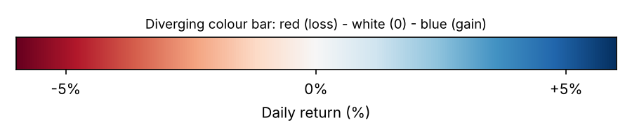

Q4. Table to Visual: Colour as a tool to highlight

(a) What to highlight and why [2]
Highlight Milk, which has the highest Units_K (85K). A single highlighted bar lets the reader see the key message at a glance. The eye is drawn to the one distinct colour before reading any numbers.

(b) Sketch of the bar chart and colours [4]
- Highlighted bar (Milk): orange, #E66100.
- Other six bars: light grey, #BDBDBD.
Axis: products on the x-axis, Units_K on the y-axis, with a title such as "Units sold by product". No legend is needed.
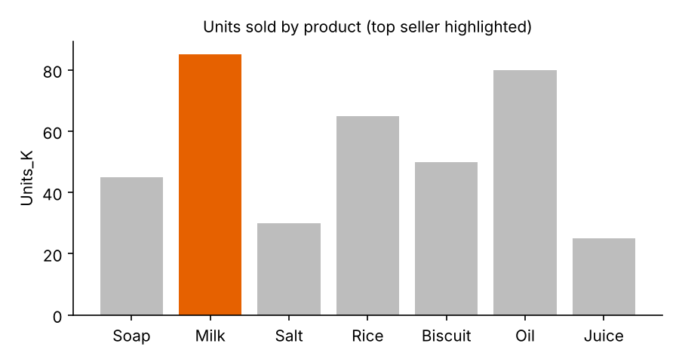

(c) Colour-scale type used [2]
This is a qualitative scale used as an accent: one accent hue (orange) against neutral greys, so colour marks "the highlighted bar" versus "the rest". It is not sequential or diverging because colour here carries no numeric order. A rainbow palette would be a poor choice because it gives every bar a different loud colour, so no bar stands out, the emphasis is lost, and the colours falsely suggest seven different categories or an order.

(d) One way to keep the highlight visible for colour-blind readers [2]
Add a direct value label on the highlighted bar (for example "85K"). In addition, pick an accent that differs strongly in lightness from the grey (a dark blue or dark orange against light grey), so the bar stands out even without hue.

Q5. Visual to R Code: Colour as a tool to highlight [10 marks]

(a) Complete R (ggplot2) program [7]
library(ggplot2)

# data frame
df <- data.frame(
Branch = c("Kolkata", "Pune", "Jaipur", "Chennai", "Delhi", "Surat"),
Sales_Lakh = c(785, 595, 715, 670, 390, 495)
)

# highlight logic: top branch is flagged, others are not
df$Highlight <- ifelse(df$Sales_Lakh == max(df$Sales_Lakh), "Top", "Other")

# ggplot call
ggplot(df, aes(x = reorder(Branch, Sales_Lakh),
y = Sales_Lakh, fill = Highlight)) +
geom_col() +
scale_fill_manual(values = c("Top" = "#E66100", "Other" = "grey70"),
guide = "none") +
coord_flip() +
labs(x = NULL, y = "Sales_Lakh") +
theme_minimal()

Resulting chart (horizontal bars, sorted, top branch highlighted):
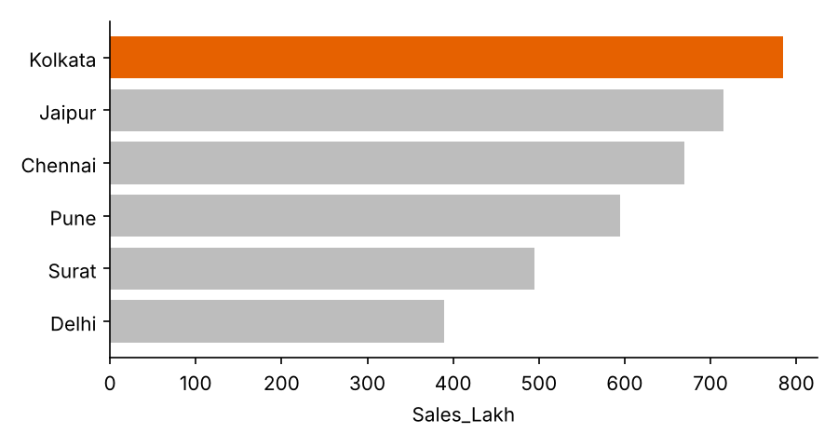

(b) Colour technique and why the other bars are grey [3]
The technique is highlight (accent) colouring: one strong accent colour on the bar of interest and a neutral grey on everything else. Grey is used for the other bars because it recedes into the background. This keeps them visible as context for comparison but stops them competing for attention, so the reader sees the top branch (Kolkata, 785 lakh) first.

